# Name: ______________________ Seat # ____

**Homework 4 - On Lecture 4 - Classes II**

**(100 points) Hours:**

**The homework is to be turned in as a *PAPER AND PENCIL i.e., HANDWRITTEN ANSWER ONLY!(with your terminal #!)* in the first ten minutes of the due date class.**

**Also an implementation in NetBeans Java is ALSO required, thus you are to submit the ZIPPED project to BB and download it in 232 PGH the first 10 minutes of class. Hardcopy with screenshots of the running program and the SOURCE CODE are also needed.**

**TURNING IN THE HOMEWORK INSTRUCTIONS will be PENALTY OF -10 points.**

**I UNDERSTAND THAT TURNING ANOTHER’s WORK IN is CHEATING.**

**I UNDERSTAND THAT ANY KIND OF DISSEMINATION of this WORK is CHEATING.**

**I CERTIFY THAT THE HOMEWORKs SOLUTIONs ARE MY OWN WORK!**

**?**

**X**

**V**

**SIGNATURE:**

**HOMEWORK CHECKLIST (YOU MUST GRADE YOURSELF!):**

**TA check, is Homework4.doc & Homework4.zip**

**in BB?**

1. **DID TURN IN HOMEWORK INSTRUCTIONS?* -10 points**
2. **1.? 33 points**
3. **2.? 12 points**
4. **3.? H & E (attach to BB) – WORD ONLY 55 points**

1. **Homework4 JAVA.zip NOT submitted to BB? * -35 points**
2. **Homework4 JAVA.zip NOT running in class? * -35 points**

* **If NOT, do not enter anything in the box!**

TA **grade or check**

**PLEASE ENTER YOUR GRADE IN THIS BOX:**

**Screenshot?**

**By Hand?**

**I understand that if the .zip file is NOT in BB and I did not check the BOX, I will get a ZERO for the Homework!**

# 1. (33 pts) (BY HAND):

a. (3 pts)Can a class contain both static and nonstatic (that is, regular) methods?

**ANSWER:**

b. (3 pts) Can you invoke a nonstatic method within a static method?

**ANSWER:**

c. (3 pts)Can you invoke a static method within a nonstatic method?

**ANSWER:**

d. (3 pts)Can you reference an instance variable within a static method? Why or why not?

**ANSWER:**

e. (3 pts) What is the difference between a static variable and an instance variable?

**ANSWER:**

f. (3 pts)Can you use an instance variable ( without an object name and dot) in the definition of a static method of the same class? Can you use an instance variable (with-out an object name and dot) in the definition of a nonstatic (ordinary) method of the same class?

**ANSWER:**

g. (3 pts)Can you use a static variable in the definition of a static method of the same class? Can you use a static variable in the definition of a nonstatic ( ordinary) method of the same class?

**ANSWER:**

h. (3 pts)Can you use the this parameter in the definition of a static method?

**ANSWER:**

i. (3 pts)What is the output produced by the following code?

Character characterObject1 = new Character(' a');

Character characterObject2 = new Character(' A');

if ( characterObject1. equals( characterObject2))

System. out. println(" Objects are equal.");

else

System. out. println(" Objects are Not equal.");

**ANSWER:**

j. (3 pts)Suppose result is a variable of type double that has a value. Write a Java expression that returns a string that is the normal way of writing the value in result.

**ANSWER:**

k. (3 pts)Suppose stringForm is a variable of type String that names a String that is the normal way of writing some double, such as " 41.99". Write a Java expression that returns the double value named by stringForm.

**ANSWER:**

# 2. (12 pts) (BY HAND)

a. (3 pts)What is a reference type? Are class types reference types? Are primitive types (such as int) reference types?

**ANSWER:**

b. (3 pts) When comparing two objects of a class type to see if they are “ equal” or not, should you use == or the method equals?

**ANSWER:**

c. (3 pts) When comparing two objects of a primitive type ( such as int) to see if they are “ equal” or not, should you use == or the method equals?

**ANSWER:**

d. (3 pts) Can a method with an argument of a class type change the values of the instance variables in the object named by the argument? For example, if the argument is of type ToyClass defined in Display 5.11 (A Simple Class), can the method change the name of its argument?

**ANSWER:**

**3.** (55 pts) **UML Class Diagram** (**MICROSOFT WORD; Textual Analysis – TA Cut&Paste&Rearrange**).

a. (10 pts)Draw the **UML** Class Diagram (**REVERSE ENGINEERING**)

ToyClass2(2):name:String

ToyClass2(3):number:int

ToyClass2(1):ToyClass2(String, int)

Create a Class ToyClass2 with instance variables name and number and method **set** that will set the name and number, method **tryToMakeEqual** that takes an integer, method **makeEqual** that takes a class parameter of ToyClass2, the method **equals** and **toString**.

ToyClass2(8):toString():String

ToyClass2(7):equals(ToyClass2):bool

ToyClass2(6): makeEqual(ToyClass2):void

ToyClass2(5):tryToMakeEqual(int):void

ToyClass2(4):set(String, int):void

**ANSWER:**

Any DIAGRAM that is NOT the result of CUT and PASTE

WILL BE IGNORED (YOU WILL GET ZERO POINTS)

|  |
| --- |
| Main |
|  |
| + main(String[] args):void |

|  |
| --- |
| ToyClass2 |
| - ToyClass2(2):name:String  - ToyClass2(3):number:int |
| + ToyClass2(1):ToyClass2(String, int)  + ToyClass2(4):set(String, int):void  + ToyClass2(5):tryToMakeEqual(int):void  + ToyClass2(6): makeEqual(ToyClass2):void  + ToyClass2(7):equals(ToyClass2):bool  + ToyClass2(8):toString():String |

b. (35 pts) **Create** **in Netbeans 6.9.1 HOMEWORK4 Project build and run .**

**ANSWER:**

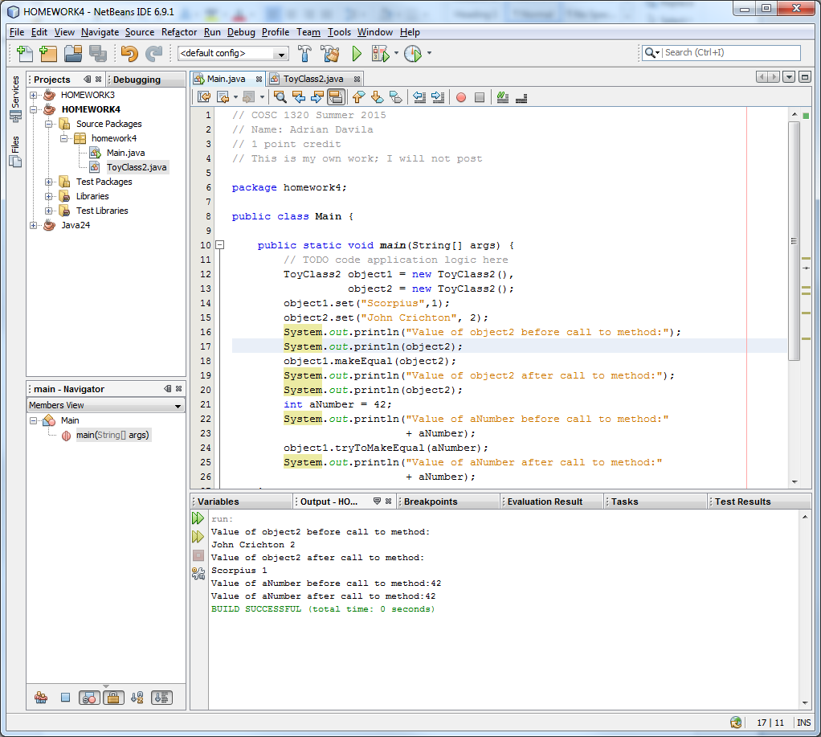

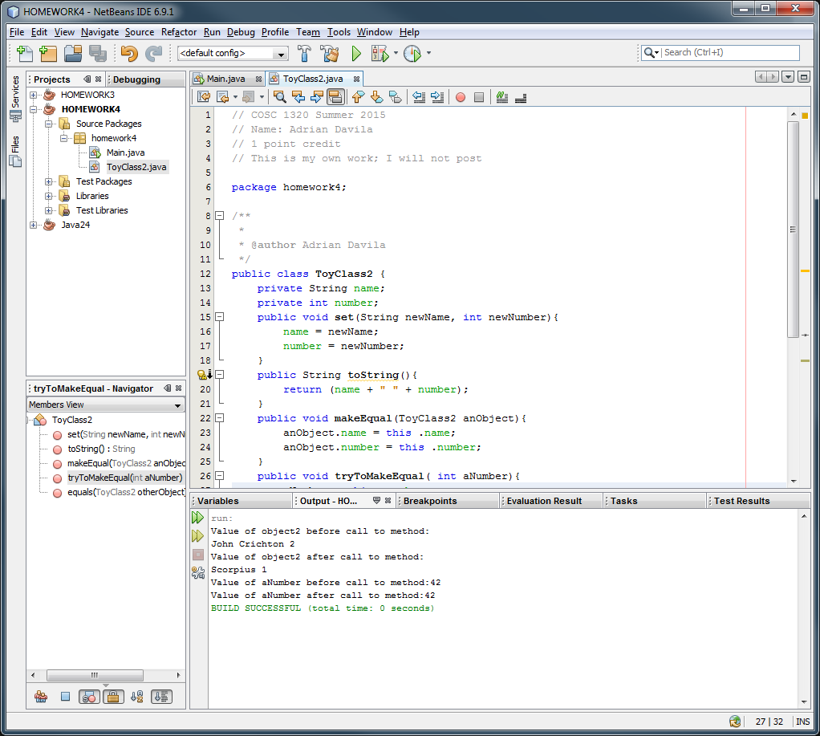

c. (10 pts)Answer the following based on b. (**BY HAND**):

What is the problem with **trytoMakeEqual** method?

**ANSWER:**

